**ACCEPTANCE TEST PROCEDURE**

**FOR**

**“24" LED DISPLAY – INDUSTRIAL”**

**(BEL Part No: - 4461 413 002 56)**

|  |  |  |  |
| --- | --- | --- | --- |
| **P.O. No.** | **BEPO/GD1/4000397005** | **DATED:** | ***05-07-2023*** |
| **PREPARED BY.** | **PURUSHOTHAM REDDY** | **APPROVED BY** | **Mr**. **RAJMOHAN. K** |
| **SIGNATURE.** |  | **SIGNATURE.** |  |
| **BEL (Rep) NAME** | **Mr**. | **APPROVED BY.** | **Mr**. |
| **SIGNATURE.** |  | **SIGNATURE.** |  |

**SUPPLIED TO:**



**M/S BHARAT ELECTRONICS LIMITED,**

**MANUFACTURED BY:**



**M/S DATASOL (B) PVT. LTD,**

**BANGALORE – 560 045.**

TABLE OF CONTENTS

|  |  |  |
| --- | --- | --- |
|  | **DESCRIPTION** | **PAGE NO** |
| 1.0 | Scope | 3 |
| 1.1 | Identification | 3 |
| 1.3 | Brief Description | 4 |
| 2.0 | Specifications | 4 |
| 3.0 | Test Equipment Required | 4 |
| 4.0 | Physical Inspection | 5 |
| 5.0 | Functional Test Procedure | 5 |
| 6.0 | Hardware Details | 6 |
| 6.1 | Display Specification | 6 |
| 6.2 | Power Supply Specification | 7 |
| 6.3 | AC Power Entry Modules | 8 |
| 7.0 | Block Diagram | 9 |
| 8.0 | Test Setup | 9 |
| 9.0 | Wiring Details | 10 |
| 9.1 | Panel AC Connector To ON/OFF Switch and Power Supply Connection | 10 |
| 9.2 | ON/OFF Switch to Power Supply I/P | 10 |
| 9.3 | Power Supply O/P To AD Board | 11 |
|  | Physical Test Report-TDR-1 | 12 |
|  | Functional Test Report - TDR-2 | 13 |

**Images**

|  |  |  |
| --- | --- | --- |
|  | **DESCRIPTION** | **PAGE NO** |
| Image1 | DBPL-24HD-01 | 3 |
| Image2 | Display | 6 |
| Image3 | Power Supply | 7 |
| Image4 | AC Power Entry Module | 8 |
| Image5 | Block Diagram | 9 |
| Image6 | Test Setup | 9 |
| Image7 | Wiring Details | 10 |

**1.0 SCOPE**

This document defines the procedure that is to be followed during the process of acceptance of the

24” LED Display-Industrial for fulfilling the needs of BEL GBD, as per the Purchase Order.

* 1. **IDENTIFICATION**

The 24” LED Display-Industrial supplied by M/S Datasol to M/S Bharat Electronics Limited will be here after identified as given below.

Description : 24” LED Display-Industrial

MFG P/N : DBPL-24HD-01

BEL Part Number : 446141300256

MFG Year : 2023

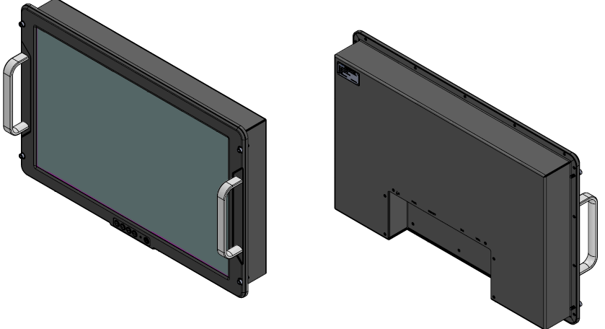

**Image1 - DBPL-24HD-01**

**1.3 Brief Description**

24” LED Display-Industrial is a colour active matrix TFT LCD module using amorphous silicon TFT's (Thin Film Transistors) as an active switching device. This module has a 24 inch diagonally measured active area with WUXGA resolutions (1920 horizontal by 1200 vertical pixel array). Each pixel is divided into RED, GREEN, BLUE dots which are arranged in vertical stripe and this module can display 16.7M colours. The TFT-LCD panel used for this module is adapted for a low reflection and higher colour type.

**2.0: Specifications**

* **Front panel Control:** OSD control keypad
* **Connection:** AC Input, VGA, DVI Connector
* **Display:** 24” with resolution 1920 X 1200
* **Dimensions (W x H x D):** Details in TDR-1
* **Weight:** < 14 Kgs

**3.0: Test Equipment Required:**

Test PC - 1 No

DVI Cable - 1 No.

VGA cable -1 No

Power chords -2 No

Keyboard -1 No

Mouse -1 No

**4.0: Physical Inspection**

1.Check the Display for any damages

2. Check if the power circular connector is properly mating at the Display end and also clearly inserted at the power socket.

3. Check all the connectors, power & signal for any loose pins/wires.

4. Check the measurements as specified in TDR-1 and note down the result in TDR-1.

**5.0: Functional Test Procedure:**

1. Connect the Display to the CPU of a PC. After switching ON the power to Display check the system booting and display seen on the screen of Display.

2. Check the Resolution 1920x1200

3. Note down the results in TDR-2.

4. After checking, shutdown the system and switch off the Display Unit.

**6. Hardware details:**

**6.1. Display Specification**

**P/N: EV240WUM-N10**

EV240WUM-N10 is a colour active matrix TFT LCD module using amorphous silicon TFT's (Thin Film Transistors) as an active switching device. This module has a 24 inch diagonally measured active area with WUXGA resolutions (1920 horizontal by 1200 vertical pixel array). Each pixel is divided into RED, GREEN, BLUE dots which are arranged in vertical stripe and this module can display 16.7M colours. The TFT-LCD panel used for this module is adapted for a low reflection and higher colour type.

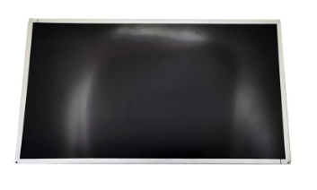

**Image2 - Display**

**Features**

* Real 8-bit colour depth, display 16.7M colours
* Compatible with Colour Gamut 72%@NTSC (CIE 1931)
* High luminance and contrast ratio, low reflection and wide viewing angle
* DE (Data Enable) only
* RoHS/Halogen Free
* Gamma Correction

|  |  |
| --- | --- |
| **Parameter** | **Specification** |
| Resolution | 1920×1200 |
| Contrast Ratio | 1000:1 |
| Display Colours | 16.7M |
| Brightness | 600 |
| Viewing angle U/D/L/R | 89/89/89/89 |
| Display Size | 24” |
| Frame Rate | 60Hz |
| Operating Temperature | 0 ~ 50 °C |

**6.2. Power supply Specification**

**P/N: LFA100F-12**

Cosel LFA AC-DC Converters are compact, lightweight, and wide input rugged PCB type AC-DC converters. Features include small and compact PCB construction, built-in inrush current, overcurrent, and overvoltage protection circuits and universal input (AC85 - 264V). These LFA converters are compatible to worldwide safety standards, including UL, C-UL, TUV standard and CE mark. These components are compatible to various safety standards in major countries.

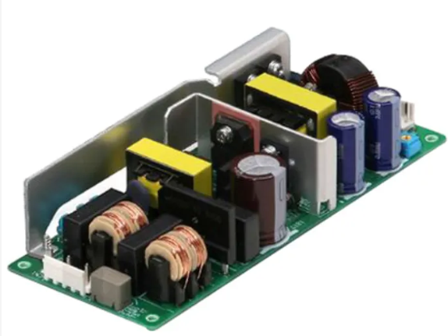

**Image3 -Power Supply**

**Feature**

* Small and compact PCB construction
* Built-in inrush current, overcurrent and overvoltage protection circuits
* Harmonic attenuator (Complies with IEC61000-3-2)
* Universal input (AC85-264V)
* MAX O/P 102W
* DC O/P 12V, 8.5A

|  |  |
| --- | --- |
| **Parameter** | **Specification** |
| Input Voltage | 85 VAC to 264 VAC |
| Output Voltage-Channel | 12 VDC |
| Output Current-Channel | 8.5 A |
| Input Frequency | 50 Hz/60 Hz |
| Power - Convection | 102 W |
| OPERATING TEMP. | -10 to +70C |

**6.3. AC Power Entry Modules Specification**

**P/N: FN9262-10-06**

The FN9262 power entry module combines an IEC inlet, mains filter with very high filter attenuation based on nanocrystalline material selection and fuses in a small form factor. Choosing FN9262 product line brings you rapid availability of a standard filter associated with the necessary safety acceptances. Standard IEC connector filters are a practical solution helping you to pass EMI system approval in a short time. A wide selection on amperage ratings, mounting possibilities and filters for medical applications (acc. to IEC 60601-1 with low leakage current and high performance) are designed to offer you the desired solution.

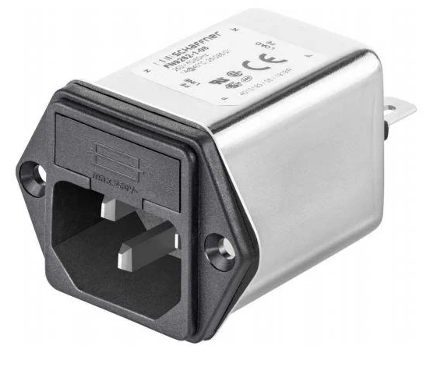

**Image4 -AC Power Entry Module**

**Features and Benefits**

* Exceptional conducted attenuation performance, based on chokes with high saturation resistance and excellent thermal behaviour
* FN9262B versions comply with the requirements of 1MOP acc. toIEC/EN 60601-1 for creepage and clearance, leakage current and high potential testing
* Versions up to 10 A are available with fuse holder for two fuses

|  |  |
| --- | --- |
| **Parameter** | **Specification** |
| Input Voltage | 250VAC |
| Output Current Rating | 10 A |
| Mounting Style | Panel Mount |
| OPERATING TEMP. | -25 to +85C |

**7. Block Diagram**

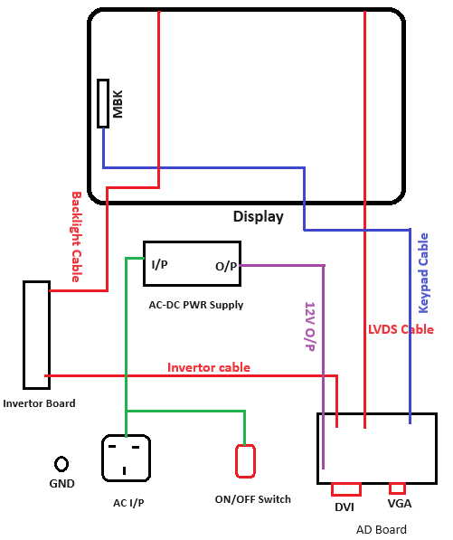

**Image5 -Block Diagram**

**8. Test Setup**

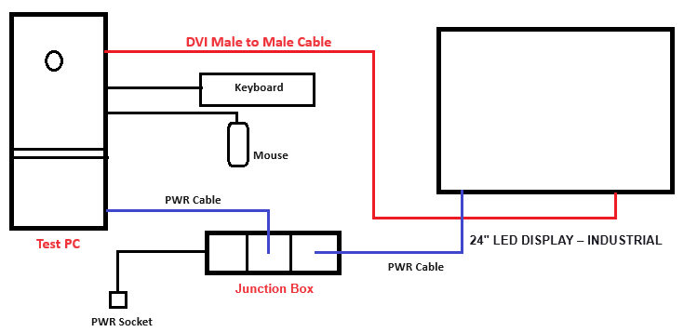

**Image6 – Test Setup**

**9. Wiring Details**

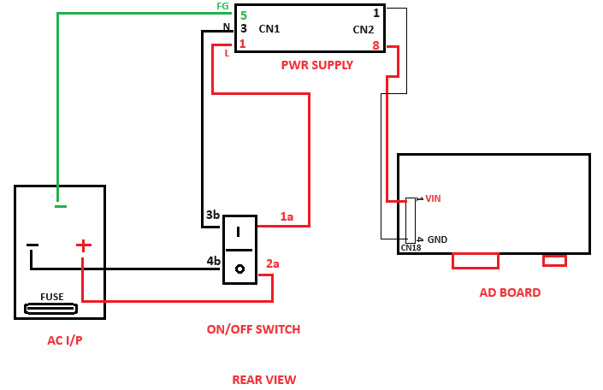

**Image7 -Wiring Details**

**9.1. Panel AC Connector to ON/OFF Switch and Power Supply Connection**

|  |  |  |  |  |  |  |
| --- | --- | --- | --- | --- | --- | --- |
| **PANEL Connector** | **Pin no** | **Signal Description** |  | **ON/OFF Switch & PWR Supply I/P** | **Pin no** | **Signal Description** |
| **FN9262-10-06** | + | LINE | ------> | **H8550VBBBEN551W** | Pin 2a | LINE |
| - | NEUTRAL | ------> | Pin 4b | NEUTRAL |
| FG | EARTH | ------> | **LFA100F-12** | Pin 5 | FG |

**9.2. ON/OFF Switch to Power Supply I/P**

|  |  |  |  |  |  |  |
| --- | --- | --- | --- | --- | --- | --- |
| **ON/OFF Switch** | **Pin no** | **Signal Description** |  | **PWR Supply I/P**  **(CN1)** | **Pin no** | **Signal Description** |
| **H8550VBBBEN551W** | Pin 1a | LINE | ------> | LFA100F-12 | Pin 1 | LINE |
| Pin 3b | NEUTRAL | ------> | Pin 3 | NEUTRAL |

**9.3. Power Supply O/P to AD Board**

|  |  |  |  |  |  |  |
| --- | --- | --- | --- | --- | --- | --- |
| **PWR Supply O/P** | **Pin no** | **Signal Description** |  | **AD Board** | **Pin no** | **Signal Description** |
| **CN2** | Pin 8 | LINE | ------> | **CN18** | Pin 1 | VIN |
| Pin 1 | NEUTRAL | ------> | Pin 4 | GND |

**Physical Test Report - TDR-1 Date:**

**BEL Part No: 4461 413 002 56**

**Description: 24" LED Display – Industrial**

**Unit Serial Number:**

**PHYSICAL CHECK:**

|  |  |  |  |
| --- | --- | --- | --- |
| **S.NO** | **TEST** | **REQUIREMENT** | **RESULT** |
| 1 | 24” LED Display-Industrialdamages check | No damages | OK /NOT OK |
| 2 | Mating of power & DVI cables | Proper fitment | OK /NOT OK |

**DIMENSIONAL CHECK:**

|  |  |  |  |  |
| --- | --- | --- | --- | --- |
| **S.NO** | **DESCRIPTION** | **SPECIFIED DIMENSIONS(MM)** | **MEASURED DIMENSIONS(MM)** | **RESULT** |
| 1 | Width | 609 ± 2.0 |  | OK /NOT OK |
| 2 | Height | 399 ± 2.0 |  | OK /NOT OK |
| 3 | Depth | 81.5 ± 5.0 |  | OK /NOT OK |
| 4 | Weight | ≤14 Kgs |  | OK /NOT OK |

**RESULT: OK / NOT OK**

**Rremarks If Any:**

**Tested By: Verified By:**

**Functional Test Report - TDR-2 Date:**

**BEL Part No: 4461 413 002 56**

**Description: 24" LED Display – Industrial**

**Unit Serial Number:**

|  |  |  |  |
| --- | --- | --- | --- |
| **S. No** | **Test** | **Requirement** | **Result** |
| 1 | After switching ON the power to Display & Test PC check if the system got booted and display is seen on the screen of the unit. Set the Resolution to 1920x1200 and check if the set resolution is supported and displayed on the screen | Resolution up to 1920 X 1200 | OK / NOT OK |

**RESULT: OK / NOT OK**

**Rremarks If Any:**

**Tested By: Verified By:**